**FUNCTIONAL AND PERFORMANCE TESTING :**

|  |  |
| --- | --- |
| **DATE** |  |
| **TEAM ID** | NM2025TMID05625 |
| **PROJECT NAME** | Streamlining Ticket  Assignment For Efficient  Support Operations |

**MILESTONE -8 FLOW**

**ACTIVITY-1 Create a Flow to Assign operations ticket to group**

**PURPOSE:**

Purpose of Creating a Flow to Assign Operations Ticket to Group: The purpose is to automate the process of directing operations-related tickets to the right support group.

**USES:**

It automatically routes operations tickets to the correct group, speeding up ticket handling and improving support efficiency.

**STEPS:**

1. Open service now.
2. Click on All >> search for Flow Designer
3. Click on Flow Designer under Process Automation.
4. After opening Flow Designer Click on new and select Flow.
5. Under Flow properties Give Flow Name as “ Regarding Certificate”.
6. Application should be Global.
7. Select Run user as “ System user ” from that choice.
8. Click on Submit.

1. Click on Add a trigger
2. Select the trigger in that Search for “create or update a record” and select that.
3. Give the table name as “ Operations related ”.
4. Give the Condition as

Field : issue

Operator : is

Value : Regrading Certificates 5. After that click on Done

1. Now under Actions.
2. Click on Add an action.
3. Select action in that search for “ Update Record ”.
4. In Record field drag the fields from the data navigation from left side
5. Table will be auto assigned after that
6. Give the field as “ Assigned to group ” 12. Give value as “ Certificates ”
7. Click on Done.
8. Click on Save to save the Flow.
9. Click on Activate.

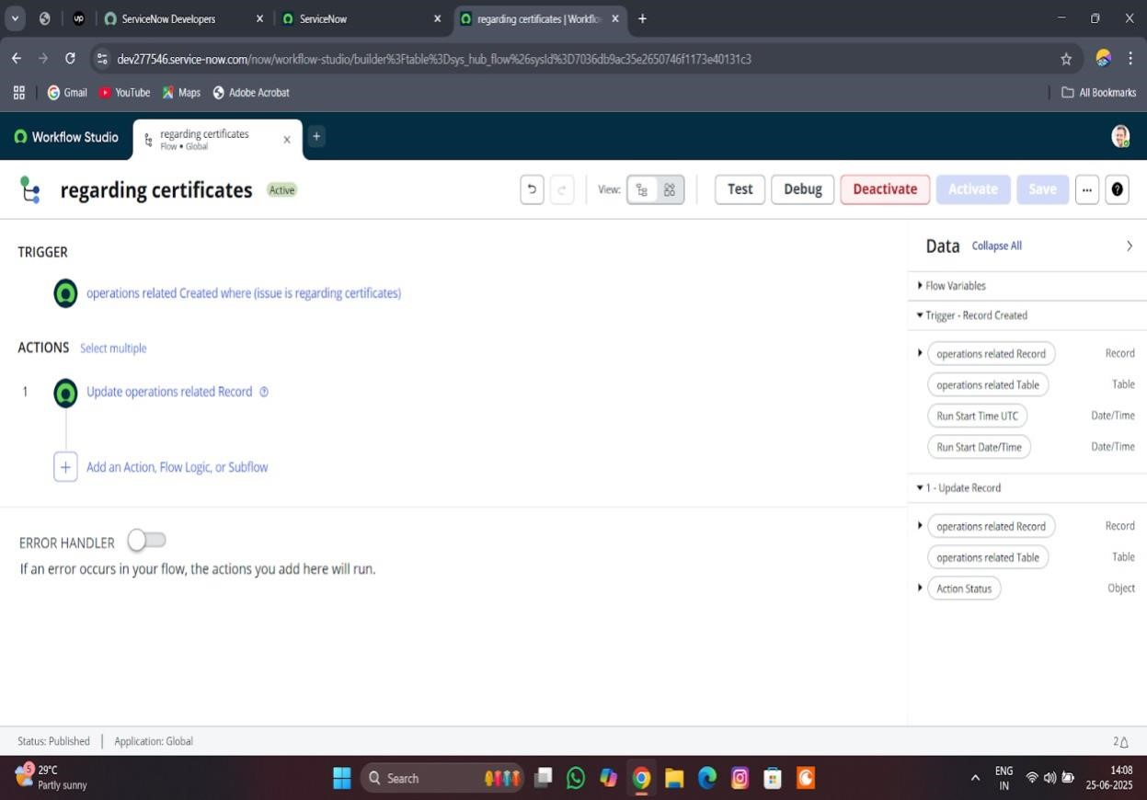

**ACTIVITY-2 Create a Flow to Assign operations ticket to Platform**

**PURPOSE:**

To automatically assign operations tickets to the right platform experts, ensuring faster and accurate support.

**USES:**

It routes operations tickets to the correct platform specialists automatically, improving response time and support accurate

**STEPS:**

1. Open service now.
2. Click on All >> search for Flow Designer
3. Click on Flow Designer under Process Automation.
4. After opening Flow Designer Click on new and select Flow.
5. Under Flow properties Give Flow Name as “ Regarding Platform ”.
6. Application should be Global.
7. Select Run user as “ System user ” from that choice.
8. Click on Submit.

1. Click on Add a trigger
2. Select the trigger in that Search for “create or update a record” and select that.
3. Give the table name as “ Operations related ”.
4. Give the Condition as

Field : issue

Operator : is

Value : Unable to login to platform

1. Click on New Criteria

Field : issue

Operator : is Value : 404 Error

1. Click on New Criteria

Field : issue

Operator : is

Value : Regrading User expired

1. After that click on Done.
2. Now under Actions.
3. Click on Add an action.
4. Select action in that search for “ Update Record ”.
5. In Record field drag the fields from the data navigation from left side
6. Table will be auto assigned after that 13. Give the field as “ Assigned to group ”. 14. Give value as “ Platform ”
7. Click on Done.
8. Click on Save to save the Flow.
9. Click on Activate.

